1. **Mallidi,Anudeep Reddy**
2. **Team D** – Phoenix
3. **Client**: Dr. Michael Oudshoorn (oudshoorn@nwmissouri.edu)
4. **Project**: Slack/Hip chat collaboration tool
5. **Team Role**: Quality and testing management
6. **Weekly Iteration plan**:

I have been assigned the role of Quality and testing management for this project. I am responsible for handling quality and testing throughout the SDLC process. I will be completing the test cases for the remaining functionalities like google drive integration, shared docs. Even though I’m bit lagging in my schedule and had a discussion with my team regarding the impact of test cases on this project and as per the discussion there isn’t much impact on the project as per the current project management plan.

Labor hour estimate: Planning to work around 40 hours this week and get my work done and have some additional hours planned to minimize the lag in the test cases development.

1. **Last week accomplishments**:

Last week I worked for 37 hours and I have designed moqups for our project and started working on the test cases for “Roles to team members”. I have done test cases and providing appropriate deliverables for the test modules. This week I am on the schedule and there is some lag in completion of the test cases. I finished writing test cases for chat and shared calendar. It may not impact the progress of the project but has to be done by the end of this week.

**Last Week’s Post:**

1. **Mallidi,Anudeep Reddy**
2. **Team D** – Phoenix
3. **Client**: Dr. Michael Oudshoorn (oudshoorn@nwmissouri.edu)
4. **Project**: Slack/Hip chat collaboration tool
5. **Team Role**: Quality and testing management
6. **Weekly Iteration plan**:

I have been assigned the role of Quality and testing management for this project. I am responsible for handling quality and testing throughout the SDLC process. I will be managing test cases and providing appropriate deliverables for the test modules. This week I am behind the schedule. I need to finish writing test cases for “Roles to team members”. It may not impact the progress of the project but has to be done by the end of this week.

Labor hour estimate: Planning to work around 39 hours this week and get my work done.

1. **Last week accomplishments**:

Last week I worked for 37 hours and I have designed moqups for our project and started working on the test cases for “Roles to team members”. I have created a moqup for user signup and login page and a moqup for logging in through google account. I also have designed a moqup to show how shared calendar in our project looks like. Here are the images 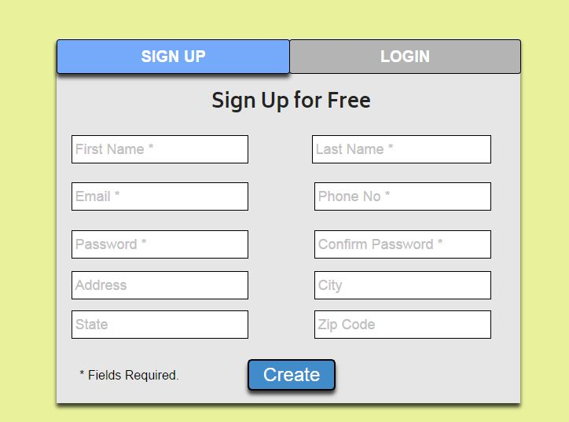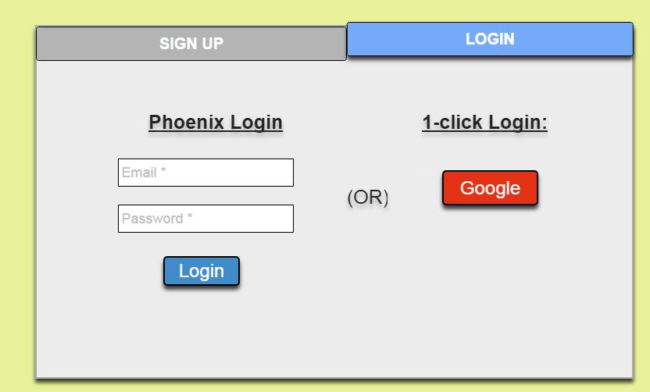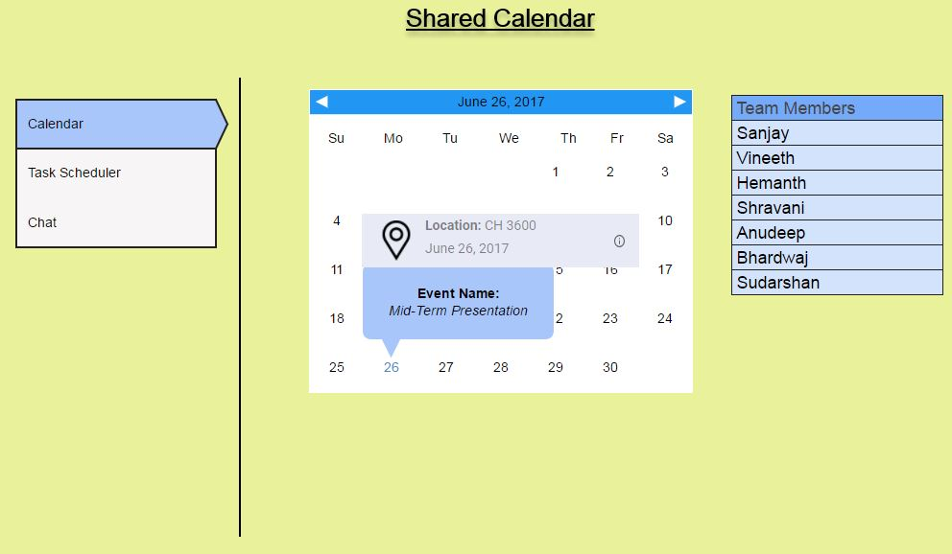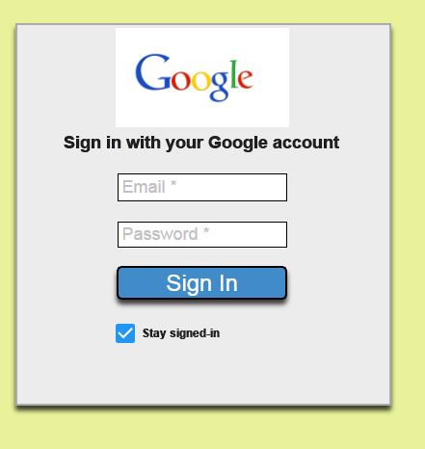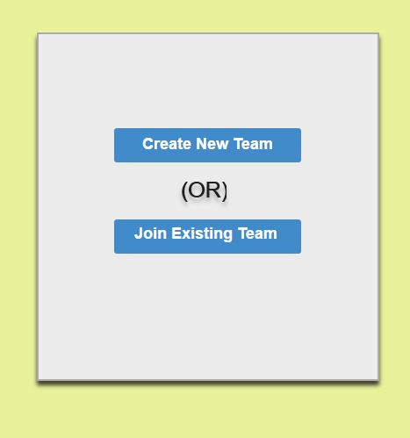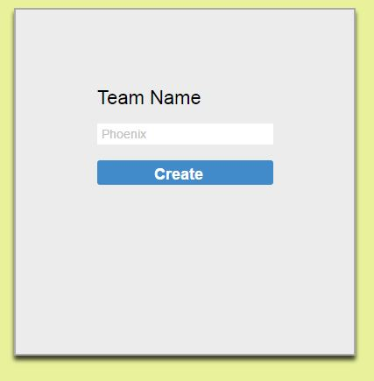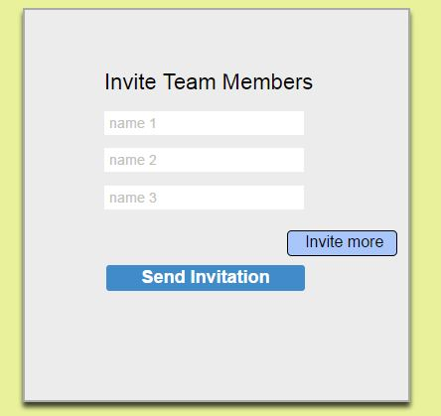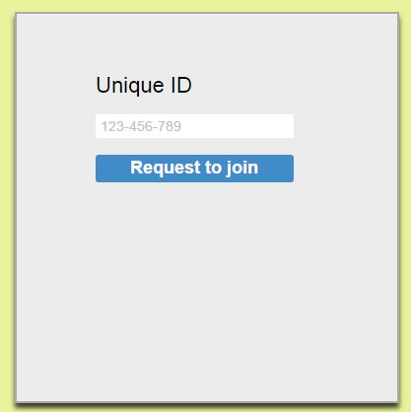

I also have gone through the client audio notes recorded by me for finalizing the requirements. Attached is a screenshot of the client audio notes

**Tasks to complete this week:**

* Will be working on designing software architecture
* Will be doing the effort distribution
* Need to do research on issuing different levels of control over the application.
* Will be finishing the use case diagrams and test cases for “roles to team members”.